The Ecological Transition in Italy

Summary
1. Indicators and territorial differences of the Italian ecological transition: the current status quo of the green revolution 2
2. The main measures and actions of the Minister of the Ecological transition, so far 7
3. Some reflections and news on the interest groups most affected by the ecological transition 9
4. Contradictions and hypocrisies of the Italian government in terms of environmental sustainability 11
5. Other observations 12

Indicators and territorial differences of the Italian ecological transition: the current status quo of the green revolution

The Plan for the Ecological Transition (Piano per la Transizione Ecologica) proposed by the Ministero della Transizione Ecologica (Mi.T.E.) focuses on different areas of intervention and aims to reach by 2030 the reduction of greenhouse gas emissions by 55% and the climate neutrality by 2050.
In the following paragraphs, I will analyze the current status quo for the main sectors of intevention, to provide a general but I hope exhaustive framework of the situation that Minister Cingolani is dealing with.

The decarbonization.
In order to incentivize the decarbonization process, investments and innovation in the renewable energy sector should be incentivized. According to the forecasts, the future expansion of the renewable sources will see as main protagonist the solar photovoltaic technology, which according to the estimates could reach between 200 and 300 GW installed. To reach the intermediate 2030 targets, the new capacity to be installed would reach approximately 70-75 GW of renewable energy. This is a significant increase, if we consider that at the end of 2019 the gross efficient power from renewable sources installed in the country was a total of 55.5 GW.
The two main obstacles are:
- the authorization difficulties (which the Pnrr aims to target)
- the slow progression of renewable capacity, which in 2019 grew just by 1,2 GW with respect to the previous year

As Figure 1 highlights, in Italy the main source of energy production is gas (39.99%), followed by oil (39.05%), hydropower (6.31%), coal (4.67%), solar (3.4%), other renewables (3.25%), wind (2.81%) and biofuels (0.52%).

Figure 1. Energy consumption by source
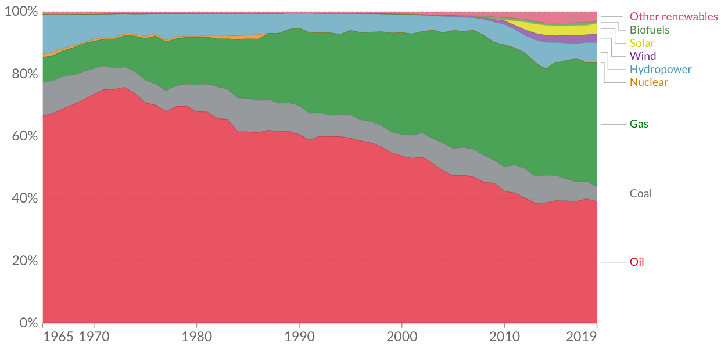
*Note. Graph and data from Our World in Data
Talking about the regional disparities in the renewable energies sector, as it can be seen from Figure 2, the Center is the area less developed. In the 2019 the electricity generation from renewable sources was distributed as follows: North 52.6%, Center 14.0%, South (including islands) 33.4%. In the North the more widespread the hydroelectric, while in the South the wind power is predominant.

Figure 2. Regional distribution of 2019 energy production from renewable resources
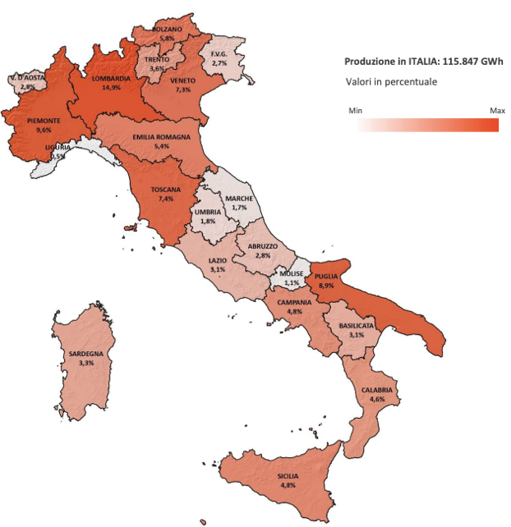
*Note. Data and image from the GSE (Gestore servizi energetici) 2019 Report.

A sore point on this topic are the judicial inquiries that in the past years brought out the existence of mafia infiltrations in the Sicilian wind power sector. A 2019 study by the Bocconi University proved how the presence of a mafia clan in the Sicilian municipalities is significantly correlated with the probability of having a wind farm while, surprisingly, the wind index is not a significant factor.

Another important issue, upon which lays a big interrogative point, concerns the nuclear energy. In Italy the door to nuclear power is closed since the 1987 referendum. The debate on the possible reintroduction of nuclear energy that had opened between 2005 and 2008 ended with the referendum of 2011, which rejected this eventuality.
However, during the climate conference held on November 2nd at Glasgow, for the Cop26, Minister Cingolani stated that the government has a cautious but not preconceived position and that it intends to wait for the assessments of the European Commission to then take a decision. The Minister has repeatedly shown a certain openness on the subject (meeting a series of resistances), insisting on the need to invest in research in this area. Currently, Italy participates to four research projects on the nuclear power, of which the main one is Iter - International Thermonuclear Experimental Reactor, in collaboration with China, Japan, India, South Korea, Russia, the United States and the other EU countries. Its purpose is the construction of an experimental plant that demonstrates the feasibility of fusion energy production (the so-called 4.0 central).

Land consumption and hydrogeological instability
Total land consumption in Italy amounts to 23,000 sq km, equal to 7.64% of the territory and the net land take in 2019 was almost 52 sq km, equal to about 2 square meters per second. This land consumption produces a potential economic damage that exceeds 3 billion euros every year.
The highest percentage values ​​of land consumed are recorded in the North, in urban and peri-urban areas and along the coasts. The 23.4% of the coastal strip within 300 meters is now artificial and in Italy, in the last 60 years, there have been setbacks of the beaches of over 90 square kilometers.
The goal of the Plan is to achieve net zero consumption by 2030 and the instruments identified to achieve so are more stringent landscape plans, tax concessions to municipalities that better preserve the ecology and more efficient and homogeneous planning on a national scale.

Moreover, in Italy the climate change is the cause of an increasing hydrogeological fragility. On a national surface of more than 300,000 sq km, 16.8% is mapped into the most dangerous classes due to landslides (8.4%) and floods (8.4%). The 91% of Italian municipalities are exposed to marked forms of hydrogeological risk while the regions most in danger are Emilia-Romagna, Tuscany, Campania, Lombardy, Veneto, and Liguria. As for industries and services, 12.4% are exposed to possible floods. There are also almost 12 thousand cultural assets potentially subject to landslides in areas of high and very high danger, and more than 30 thousand monuments at risk of flooding.
The most important factors for the triggering of landslides are short and intense rainfall, as well as the phenomena of agricultural abandonment of traditional activities in mountain areas, but also anthropogenic factors such as road cuts, excavations, and overloads have taken on an increasingly decisive role.

Water resources
The water system intended for civil, industrial, and agricultural uses can be greatly improved both in terms of quality, security of supply and the reduction of network losses, as well as for sewage and purification. As regards aquifers, the data collected by the Ispra (Istituto Superiore per la Protezione e la Ricerca Ambientale) indicate that out of 869 water bodies examined just over half are characterized by a “good” chemical status (57.6%), while the 25% with a “poor” one (of which 80% located in Calabria). The other 17.4% have not yet been classified.
Looking at regional differences on the pollutant water load purified from national purifier systems, the most polluted areas are the North-West (28.4) and the South (23.4). However, the South appears significantly behind in water management: in Sicily the service is extended to only 76.0% of residents (the average Italian value is 84.2%). The region, where the 6.4% of the population resides in 25 municipalities completely devoid of public service sewerage and the 13.3% in 80 municipalities without a public purification service), is the main recipient of the four infringement procedures against Italy, launched between 2004 and 2017, due to the failure to comply with the Community directive. Situations of non-compliance are also significant in Campania, where 7.8% of the population lives in municipalities that do not have a public purification service.

Waste management
The Italian performance in waste management is good but it can still be improved within the European framework. The annual production of urban waste, for example, equal to about 500 kilograms per capita, shows an increasingly marked decoupling with the GDP trend, which however does not emerge if we consider special waste (2.3 tons per capita). Italy currently produces about 30 million urban wastes, transferring 21% to landfills, about 20% to incineration plants with energy or heat recovery and recycling 50%, a percentage that places us among the most advanced countries.
By 2030, according to the EU objectives, 60% of the waste will have to be recycled (65% by 2035), landfilled a maximum of 10% and the rest destined for energy and heat recovery. As regards the recycling of packaging, the goal is to reach 70% by 2030. By the same date, the following objectives must be achieved in the recycling of materials present in packaging: 85% for paper and cardboard, 80% for metals ferrous, 60% for aluminum, 75% for glass, 55% for plastic, 30% for wood. In addition, single-use plastic bottles will have to be reduced by 90% by 2030.
Italy has already exceeded the recycling quotas for most of these materials (except for paper and plastic), however the waste management system still suffers from significant territorial differences, especially as regards the presence of plants. The Rapporto Sud Italia by the Green City Network and the Rapporto Rifiuti Urbani by the Ispra highlight the existence of a delay of almost all the Southern Regions compared to the national average data, still far from the urban waste recycling targets set at European level for 2030. Molise, Calabria, Puglia, Basilicata, and Campania record the greatest delays in the recycling rate of urban waste. Looking at the waste management process, all southern regions (besides Sardegna) show a delay in at least one phase of the collection and disposal system. Calabria is in the last places at the same time for three of the four phases analyzed. These data confirm that the delay is not due to problems with a particular waste supply chain, but to the overall organization and management, which simultaneously problems and issue across the municipalities.
According to a study by Utilitalia (the Association of water, energy and environmental companies), to achieve the objectives of the European legislation to 2035 - recycling at 65% and landfill below 10% - investments of 2.2 billion euros are needed in the southern peninsula and in Sicily: this is to meet the treatment needs of the organic fraction for a further 2 million tons and incineration with energy recovery for a further 1.3 million tons. Moreover, the South’s plant deficit translates into travel of waste to plants in the North, with higher costs borne by the citizens of the South: on average they pay between 355 and 360 euros for the collection of the tariff on waste, compared to 273 euros in the North and to the 322 euros of the Center.

To wrap up as said so far, I tried to build a table with the main available indicators provided by the Mi.T.E.:

Target | Indicator | Current Value | 2030 Value | Amount of Pnrr located
Decarbonization | Total carbon dioxide or greenhouse gas emissions according to national air emissions accounts | 418.000.000 t CO₂ | -55% on 1990 value  256.000.000 t CO₂ | 15.20 billion to “Renewable energy, hydrogen, grid and sustainable mobility” and 15.36 billion to “Energy efficiency and building renovation”
 | Share of energy from renewable sources in gross final consumption | 18,18% | 72% of electricity production
Sustainable mobility | Number of electric/hybrid cars | 6% of the market | 25% of the market | 8.58 billion to “Sustainable mobility”
 | GHG emissions from transport sector | 104,386,270 t CO₂ | about - 30%
Land consumption and hydrogeological instability | % population exposed to landslides risk | 2.2% | reduce the poulation at risk to 0.25 million | 8.99 billion to “Protection of the territory and of the water resource”
 | % population exposed to flood risk | 10.4% | securing 1.5 million people
Improvement of water resources and infrastructures | Leakage from the municipal water network | 37.3% of the water fed into the network was lost | 15% reduction in fragmentation and waste by 2026 | 4.38 billion to “Ensure the sustainable management of water resources and the improvement of water quality
Sea protection | Marine protected areas | 19% national water | 30% national water
Restoration and strengthening of biodiversity | Protected areas | 10.5% land surface  3% rigorous protection | 30% land surface  10% rigorous protection | 1.69 billion to “Safeguard air quality and biodiversity”
Circular economy | Circular use rate of materials | 19% | 30% | 2.10 billion to “Improve an efficient waste management and the circular economy practices”

The main measures and actions of the Minister of the Ecological transition, so far

The work of the ministry for ecological transition has mainly focused on defining and laying the foundations for the implementation of the Pnrr. In the last period, the name of Minister Cingolani has been repeated often, by the Italian press, in reference to his participation in Cop26.
On April 2021, during the work of the first meeting of the CIPESS (Interministerial Committee for Economic Planning and Sustainable Development), the 2020 Report on the state of implementation of the SNSvS (Strategia Nazionale per lo Sviluppo Sostenibilie) was presented by the Ministry of Ecological Transition. The three-year review of the strategy began already in September 2020 (before the current ministry took office) and the process is aimed at:
- guarantee the coverage of missing contents (ex. targets and indicators) dedicated to each national goal for sustainable development;
- reconfigure the contents and the role of the vectors of sustainability, to support the sustainable relaunch of the country and the transformation required by the 2030 Agenda;
- strengthen relationships with central institutions for the consolidation of the governance for sustainability;
- build on already active interlocutions and collaborations at territorial levels.

At the same time, the Project on "Policy Coherence for Sustainable Development: Integration of Sustainable Development Goals in Italian Decision-making Processes" (PCSD) was activated. The PCSD, created in collaboration with the OECD and the European Commission, intends to build an implementation tool for the integration of sustainable development policies.

I provide a list, below, of the measures taken by the ministry:
- Decree of June 22nd, 2021, on the approval of the proposals presented by the Manager of Energy Markets S.p.A. of amendments to the electricity market regulations aimed at integrating the national intraday market with the Single-Intraday Coupling Europe. The Single Intraday Coupling (SIDC) is a European project aimed at the implementation of a mechanism, in line with the requirements of the European CACM Regulation ("guideline on Capacity Allocation and Congestion Management"), which allows the negotiation of electricity continuously in the intraday timeframe;
- Decree of June 1st, 2021, on the adoption of the classification of land within the "Bortolotto-Sogeri" Vast Area for the purposes of agricultural use. In the area there is an imposing landfill, and it was necessary to differentiate highly polluted areas from those where agricultural activity is not prohibited;
- Decree of June 1st, 2021, on the adoption of the classification of land within the “Lo Uttaro” Vast Area for the purposes of agricultural use. As above, the presence of a landfill required a regulation on the arable area;
- Decree of September 2nd2021 about the Organization of the PNRR-PNIEC Technical Commission;
- Decree of September 3rd, 2021, concerning the Definition of the remuneration of the PNRR-PNIEC Technical Commission;
- Decree of September 14th, 2021, concerning changes on the guarantee fund for the construction of interconnectors, which can now also be used for sureties;
- Decree of October 28th, 2021, on the approval of the discipline of the remuneration system for the availability of electricity production capacity and definition of the target value of the system adequacy indicator, with the launch of the procedures for carrying out the auctions for the procurement of capacity for the year 2024.

Maximum effort has been also made to consolidate the process of involving non-state actors. At the end of September, in Milan, the Youth4Climate event was held and also the minister Cingolani participated to it. About 400 young people, aged between 15 and 29, from all over the world joined the event, that for the first time preceded the pre-Cop26. The Minister of Ecological Transition Roberto Cingolani proposed to make permanent, to involve young people in decision-making processes: “Our aim is to ensure that meetings like this can be held every year before the official negotiations”, said Cingolani.

Some reflections and news on the interest groups most affected by the ecological transition

In April 2021, President Draghi summoned the directors of Stellantis, Eni, Enel, Snam and Terna to Palazzo Chigi. All these companies have started projects to promote the energy transition for some time: Stellantis works on electric cars and batteries, Eni on biorefineries and biofuels, Enel holds the leadership in renewables, Snam is active in the hydrogen and gas field and Terna is concentrated on the development of resilient and sustainable networks. However, the interests at stake are many and it is not without friction that they are working towards the desired transition.

Coal-fired power plants are an example of this: just last week a very interesting article was published by L'Essenziale, the new newspaper of the editorial team of the Internazionale, on the problem of coal plants currently present in Italy and how it is difficult for the state to find a compromise between environmental interests and those of companies. Currently, in Italy there are 7 plants, 5 belonging to the Enel company (and 23,6% of state ownership), one to the A2A company and the last to the Ep company. According to the government, in order to achieve the abandonment of the coal by 2030 what must occur is a transition phase based on turbogas. As also Cingolani has pointed out "currently it is impossible to imagine a future based on renewable energy without going through gas first. It is first necessary to ground the projects of renewable sources. And after, in any case, a certain percentage of gas serves to stabilize the network from variations in the production of wind and photovoltaic ". The Minister Cingolani has a very strong position in this regard, which puts aside ideology in favor of concrete and practical realism. Indeed, this is the line proposed by the Pnrr and the Integrated National Plan for the Energy and the Environment, on which Enel, A2A and Ep are relying for the conversion of its plants: only passing through the use of hydrogen, bioenergy and climate-altering gases in those sectors defined as "hard to abate" (mainly steel, concrete, glass, aluminum and refining) it will be possible to bring decarbonization objectives closer.
However, there are some criticisms on the actual need for the transition phase based on gas that the government defined. Michele Governatori, energy manager of the Ecco study center, takes a completely different opinion, according to which "In Italy coal plants are already residual, they produce little energy compared to the total capacity" and therefore could simply be decommissioned.
Another sore point concerns the capacity market: born in 2019, this market aims to remunerate the ability to produce energy in case of need through specific auctions. In practice, you pay for potential energy, which will be produced only if it is needed due to insufficient renewables. The government and Terna (the sole operator of the Italian unified grid) consider it an essential tool to accompany the ecological transition and to stimulate it, they offer operators an attractive remuneration (in the latest auctions, 75,000 euros per year have been assigned to new plants for each mW of capacity over a period of 15 years). For example, the conversion into turbogas that Enel would like to bring to its Civitavecchia plant could obtain up to 900 million euros in subsidies. According to the international carbon tracker observatory, the Italian capacity market could lead to the construction of gas plants that are in fact useless for 11 billion euros. As always Governatori points out, "The risk is that this perverse incentive mechanism hinders alternative conversion projects for sites already penalized by the presence of coal plants". This is what happened, for example, in Monfalcone, in the province of Gorizia, where the A2A company obtained the authorization to convert a coal-fired power plant that operated at minimum capacity with an 850 mW power plant fueled by turbogas. The municipality, which had a sustainable redevelopment project for the area, was not heard.

Regarding Eni, on an official level the company has repeatedly reiterated its "commitment to an equitable and inclusive energy transition". Last October Eni and Fincantieri signed a Memorandum of Understanding (MoU) to promote initiatives for the energy transition, through integrated solutions in decarbonization projects in the energy, transport, and circular economy sectors. It seems that in the future Eni no longer sees itself as a supplier of only oil, but as a supplier of all energies, except for coal and nuclear power.
During the Assembly for the approval of the 2020 financial statements, in May 2021, the managing director Descalzi stated that "the decarbonization of the company's energy products and operations will be achieved through activities that have already started in part and existing technologies, which will allow the doubling of the biorefining capacity in the next 4 years, the increase in the production and marketing of biomethane and hydrogen and the growth in the capacity for producing energy from renewable sources up to 60 GW by 2050”.

Contradictions and hypocrisies of the Italian government in terms of environmental sustainability

In addition to what is expressed in the previous point on the coal power plants, in Italy there are also other contradictions regarding the ecological transition.
In August the Ministry of Ecological Transition issued an authorization provision for the drilling of the "Longanesi 3 Dir" well in the municipality of Lugo (Ravenna), to extract methane to the company Padana Energia, of the Gas Plus group. The project is promoted by the company Po Valley Operations and includes a gas exploitation platform, two wells and two pipelines. The new Theodoric platform will connect to an existing one, managed by ENI and will be on the border with a recently established marine area for the conservation of protected species such as the bottlenose dolphin (cetacean of the dolphin family) and the sea turtle. According to environmentalists, the authorization goes against both national and Community regulations, given the existence of a Site of Community Importance (SIC), or "Natura 2000 site" close by, and considering that since 2010 the exploitation of hydrocarbons is prohibited by 12 noon miles from the border with marine protected areas. Furthermore, if the seabed were to be excavated, the risks of subsidence that caused the lowering of the land in the Po Delta by a few meters would return to topicality.

Another sore point concerns the TAV (“Treno ad Alta Velocità”, high speed train). At the beginning of November, despite the fact that there was hardly any talk about it in the national media, engaged with the vote on the Zan decree and with the protests in the streets on the Green Pass, the government gave the green light to a decree that extends the qualification of area of strategic interest in seven further municipalities in the Val Susa, with the aim of speeding up the construction of the Turin-Lyon high-speed train sites. That of the TAV, and the related disputes, is a project that has been dragging on for almost thirty years, in a fluctuating way. Even the data in this regard are conflicting and it is difficult to clearly understand which ones are reliable. According to some. In the 2020 the Court of Auditors of the European Union declared that the project is obsolete. Due to the various delays the costs have risen by 85% compared to the initial forecasts and even the alleged environmental benefits would not be so real: the CO2 emissions would be offset only 25 years after the commissioning of the infrastructure - which would take place in 2030. The yard will emit 10 million tons of CO2 and to recover these emissions would require an increase in rail traffic from 3 to 24 million tons and an increase in total Italy-France traffic by 30% (considering that in recent years there has not been an expected increase in passenger and freight traffic between Italy and France, but rather a significant decrease).

Other observations

One issue I think it might be interesting to discuss is the recent rise in the price of energy, across Europe. According to Jason Bordoff of Foreign Policy, the current European energy crisis can be traced back to five macro causes:
- a series of extreme weather events and unusual seasonal trends that influenced both the demand and the supply of gas (a particularly cold start to 2021 in both Europe and Asia and America, followed by a very hot summer);
- the European wind energy production below average (for long periods there was no wind);
- the strong economic recovery from the pandemic (which together with the previous points caused an increase in demand);
- the refusal of the Russian state-owned gas company Gazprom to guarantee the European Union more supplies than those required by long-term contracts;
- climate policies. The European Union requires factories and power plants to apply for an emission permit for each ton of carbon dioxide produced and to respect a maximum emission quota. These shares are bought at auction. A series of reforms have reduced the available permits, so their price has reached record highs, and is expected to continue to rise. The higher prices of permits have also raised those of natural gas, preventing the transition from gas to coal. Since coal produces more carbon dioxide, and therefore requires more permits, the price of quotas has also increased, creating a vicious circle that drives up the cost of electricity.
As the graph shows, all of this is having the consequences of increasing the cost of bills.
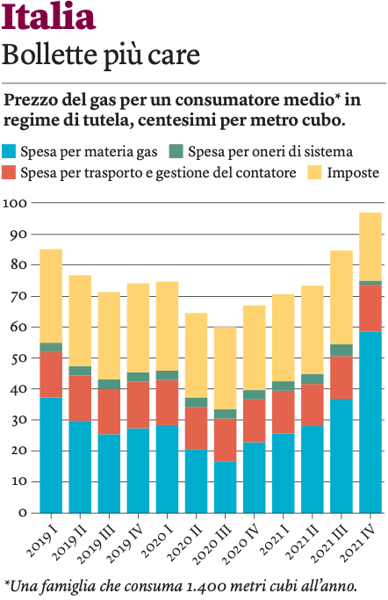
In September 2021, with a decree, over 3 billion euros were allocated to contain the bills of households and micro-enterprises, allocating 2.5 billion euros to the elimination of general system charges for the next quarter and approximately 500 million to boosting bonuses. Added to this was a 5% reduction in VAT for gas bills. It was thus possible to confirm the reduction in general system charges for the October-December quarter envisaged for the generality of electricity customers, eliminating them for domestic customers and small low voltage businesses.
As the world accelerates the shift from fossil fuels to green energy, governments must have more tools to tackle price instability. The current energy crisis is, in some ways, a foretaste of what will happen in the future if ecological conversion is not achieved quickly. It has always been difficult to maintain the balance between supply and demand for energy, and it will be even more so during the transition to clean energy, characterized by uncertainty about the times, costs of the various energy sources, the rhythm the adoption of new technologies, such as electric cars, and the rigor and duration of climate policies. Cingolani stated that "the government is committed to mitigating the cost of bills due to international economic conditions and to ensure that the transition to more sustainable energies is rapid and does not penalize families". What are the strategies that the government intends to use, what tools does it want to equip itself with to counteract the uncertainty and the relative fluctuations in supply and demand and, consequently, in prices? In broader terms, then how do they plan to keep together social issues (undermined by the increase in the cost not only of electricity, but also of fuels, for example) and sustainable and environmental ones?

